HD 160691 (µ Arae)

HD 160691 is a 1.08 M☉, G3 V star1. Based on 86 RV HARPS measurements obtained between 2003 and 2006, 40 RV CORALIE measurements obtained between 1999 and 2006, and 45 AAT measurements obtained between 1998 and 2004, a study performed in 2007 (hereafter P07)2 reported a short-period planet signal (HD 160691b) with a period of 9.6386 ± 0.0015 days, a minimum mass of 0.03321 MJup and an eccentricity of 0.172 ± 0.04, a GP (HD 160691c) signal with a period of 310.55 ± 0.83 days, a minimum mass of 0.5219 MJup and an eccentricity of 0.0666 ± 0.0122, a second GP (HD 160691d) signal with a period of 643.25 ± 0.9, a minimum mass of 1.676 MJup and an eccentricity of 0.128 ± 0.017, and a LPGP (HD 160691e) with a period of 4205.8 ± 758.9, a minimum mass of 1.814 MJup and an eccentricity of 0.0985 ± 0.0627. The CH survey reported properties of planets b, c and d close to those reported in the P07 study and HD 160691e signal with a period of 8723 days, a minimum mass of 2.49 MJup and an eccentricity of 0.43.

In the present study, in addition to the P07's dataset, 1359 RV HARPS measurements obtained between 2006 and 2015 were considered. While only one maximum of HD 160691e was observed in the P07 study's dataset, a minimum and a maximum are now covered. DPASS and MCMC (300 walkers and 1000000 iterations) were used to fit the data. To converge more easily, the priors on the semi-major axis and the minimum mass of HD 160691b were close to the values found by the P07 study. The properties of planets b, c and d are close to those reported in the P07 study. For HD 160691e, a period of 3965 days, a minimum mass of 1.8 MJup and an eccentricity of 0.08 were found with DPASS and a period of , a minimum mass of 1.84 ± 0.03 and an eccentricity of 0.07 ± 0.01 were found using MCMC.

The fits are shown in Fig 1, and the corner plot in Fig 2, and the results summarized in Table 1.

Conclusion: The properties found in the CH survey for HD 160691e are not confirmed. New orbital parameters are derived using additional data.

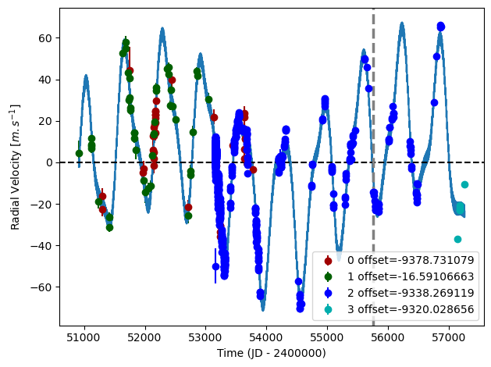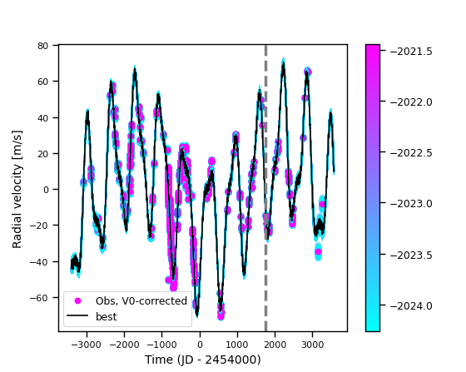

Figure 1: Fit of the HD 160691 RV with DPASS. Red - C98, green - AAT, blue - H03, cyan - H15. The blue curve shows the best fit. Right: fit of the HD 160691 RV using MCMC. The black curve shows the best fit. The colorbar corresponds to the log-likelihood of the fits. The gray dotted line indicates the end of the CH survey.

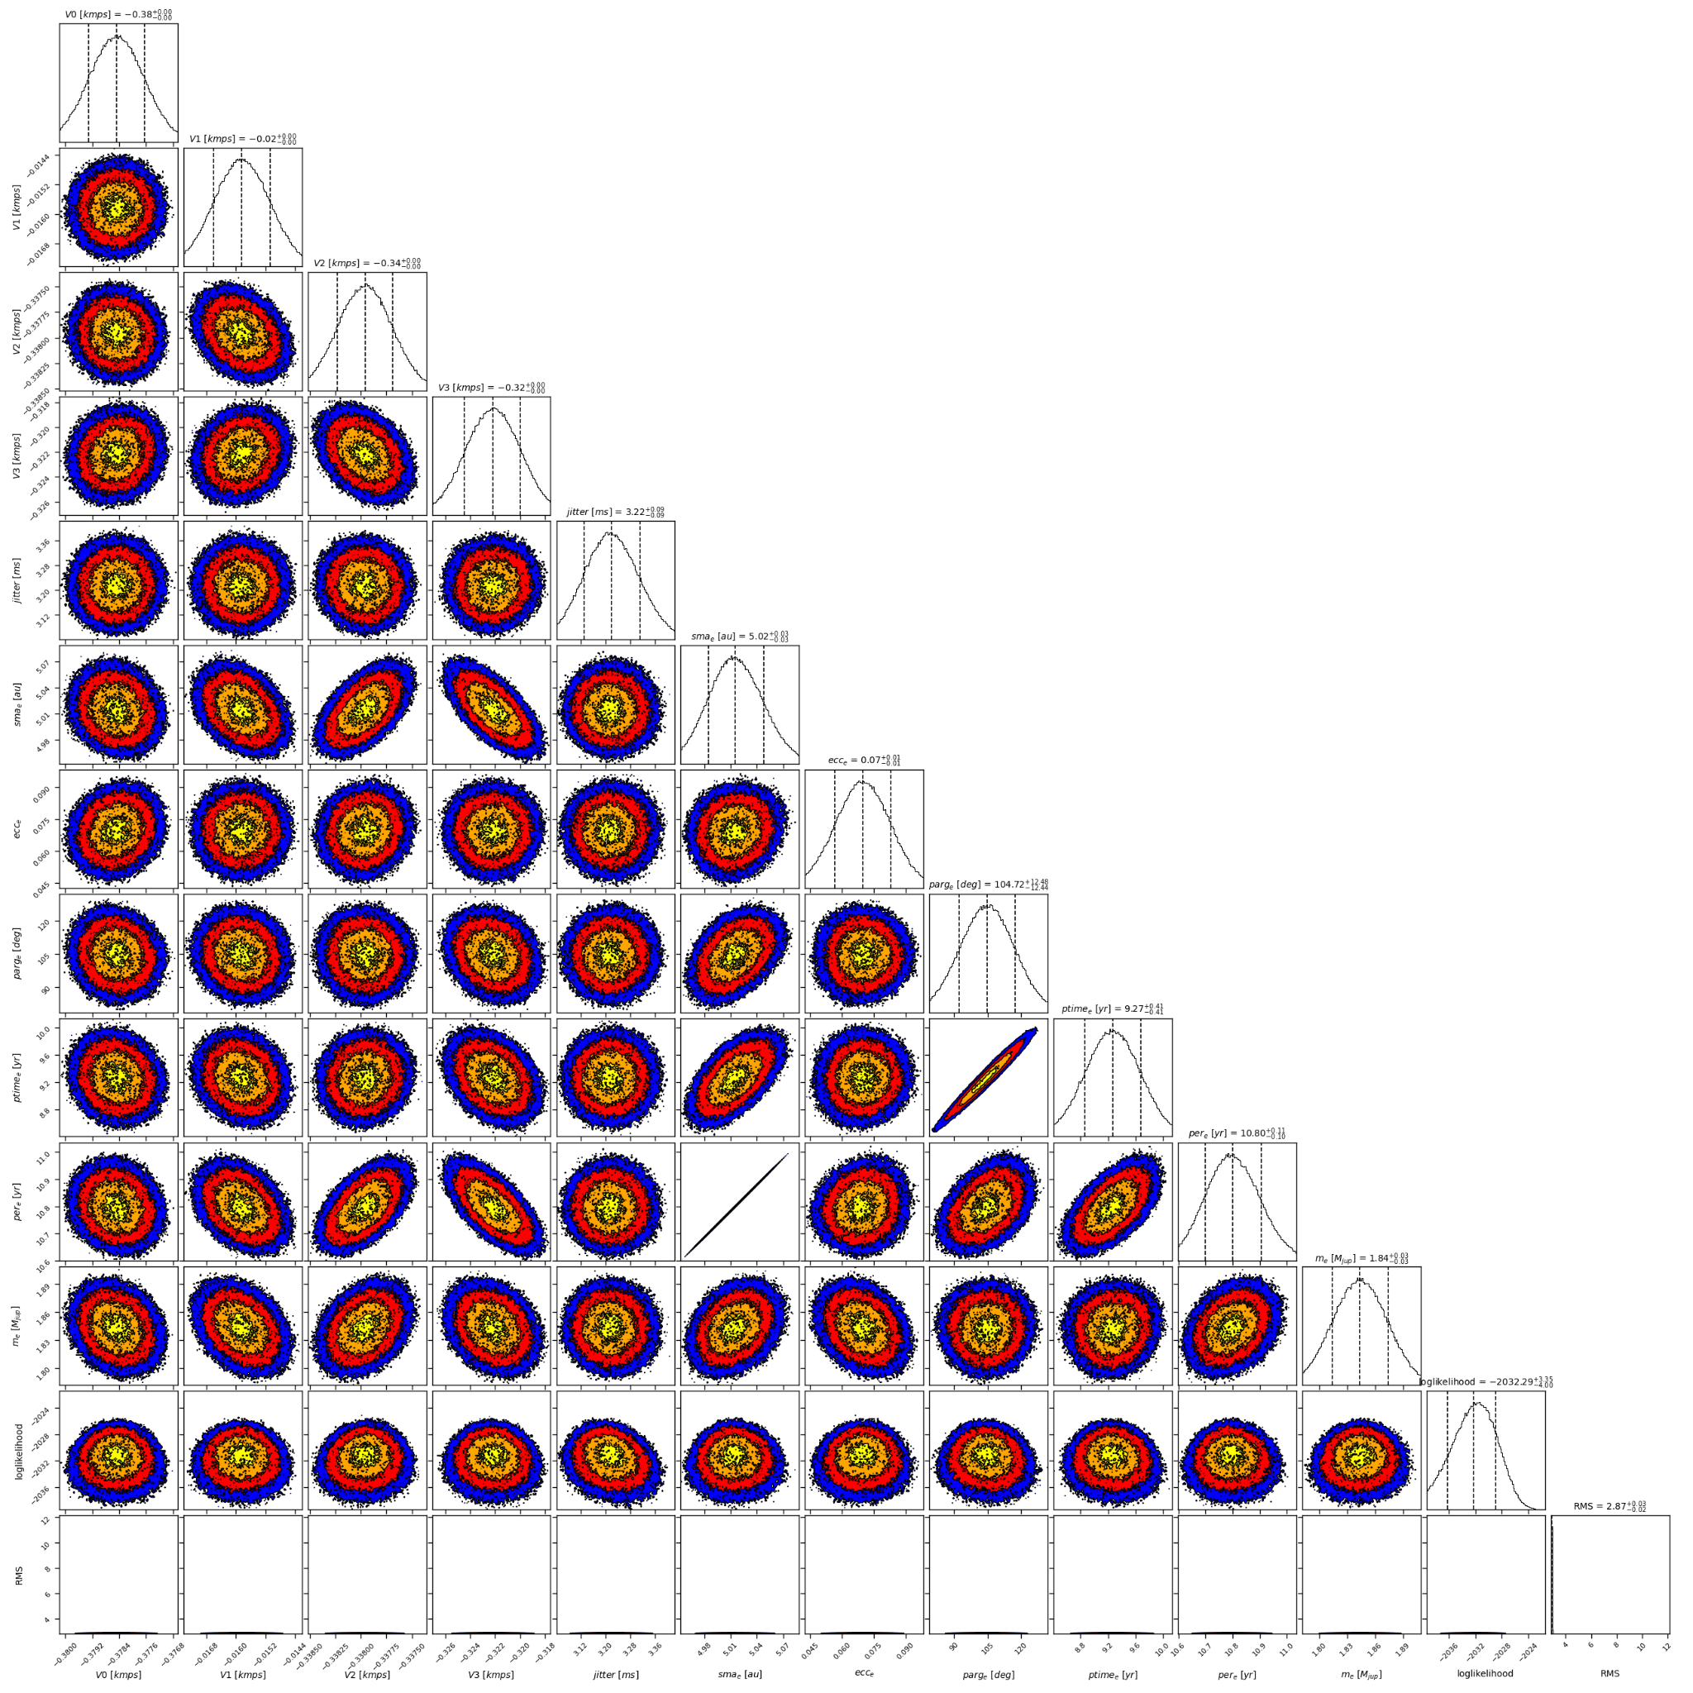

Figure 2: Corner plot of posteriors for the properties of HD 160691e.

| Parameter | Priors | | Posteriors | | CH survey |
| --- | --- | --- | --- | --- | --- |
|  | DPASS | MCMC | DPASS | MCMC |  |
| *a* (au) | b: [0.05,0.1]  c: [0,20]  d: [0,20]  e: [0,20] | b: [0.08,0.1]  c: [0.7,1.2]  d: [1.3,1.7]  e: [4,10] | b = 0.09  c = 0.9  d = 1.5  e = 5 | b = 0.091 ± 0.001  c = 0.92 ± 0.01  d = 1.50 ± 0.01  e = | b = 0.09  c = 0.9  d = 1.5  e = 8.5 |
| Msin(i) (MJup) | b: [0.01,0.5]  c: [0,50]  d: [0,50]  e: [0,50] | b: [0.01,0.05]  c: [0.1,0.6]  d: [1,2]  e: [1,10] | b = 0.03  c = 0.4  d = 1.6  e = 1.8 | b =  c =  d = 1.63 ± 0.01  e = 1.84 ± 0.03 | b = 0.033  c = 0.6  d = 1.72  e = 2.49 |
| Eccentricity | b: [0,0.2]  c: [0,0.9]  d: [0,0.9]  e: [0,0.9] | b: [0,0.2]  c: [0,0.2]  d: [0,0.2]  e: [0,0.9] | b = 0.09  c = 0.06  d = 0.0  e = 0.08 | b < 0.10  c =  d =  e = 0.07 ± 0.01 | b = 0.12  c = 0.04  d = 0.18  e = 0.43 |
| Instrumentals offsets (km/s) | [-60,60] | C98: [-10,-8]  AAT: [-1,1]  H03: [-10,-8]  H15: [-10,-8] | C98: -9.379  AAT: -0.017  H03: -9.338  H15: -9.320 | C98: -9.379 ± 0.001  AAT: -0.016 ± 0.001  H03: -9.338 ± 0.001  H15: -9.322 ± 0.002 |  |
| Stellar jitter (m/s) | [0,40] | [0,20] | 3.2 | 3.2 ± 0.1 |  |
| Argument of periastron (°) | b: [0,360]  c: [0,360]  d: [0,360]  e: [0,360] | b: [0,360]  c: [0,360]  d: [0,360]  e: [0,360] | b = 115  c = 137  d = 186  e = 144 | b = 60 – 189  c = 149 ± 28  d =  e = |  |
| Phase | b: [0,1]  c: [0,1]  d: [0,1]  e: [0,1] | b: [0,1]  c: [0,1]  d: [0,1]  e: [0,1] | b = 0.77  c = 0.15  d = 0.67  e = 0.59 | b = 0.06 – 0.95  c = 0.71 ± 0.08  d =  e = |  |

Table 1: HD 160691. Summary of priors and posteriors obtained with DPASS and MCMC, compared to the properties reported by the CH Survey.

References

1. Butler, R. et al. Two New Planets from the Anglo-Australian Planet Search. *Astrophys. J.* 555, 410-417 (2001).
2. Pepe, F. et al. The HARPS search for southern extra-solar planets. VIII. μ Arae, a system with four planets. *Astron. Astrophys*. 462, 769-776 (2007).